Name:-Sudarshan Tomar

Student ID:- 20711156 , University Roll no:- 2001152 , Gehu

**Mid-Term-Practical-Exam-Computer-Networks-PMC-202**

Q1:- There is an organization A with multiple departments. Design a network for the HR department and the size of the department is 10 users. Also, show the communication between user number 1 and user number 5 of the network.

Ans.

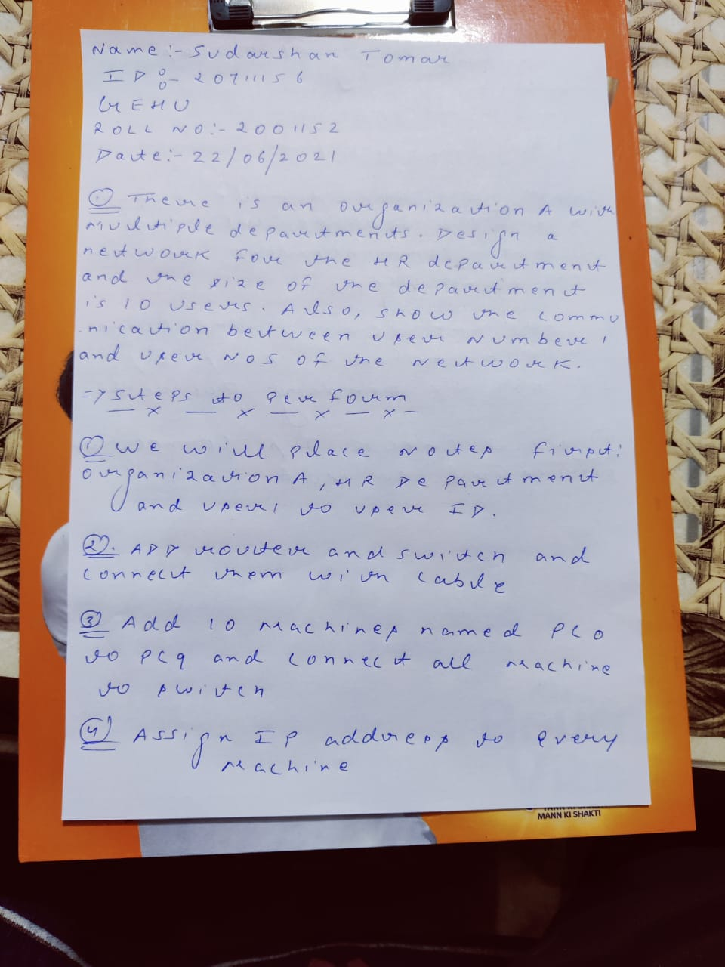

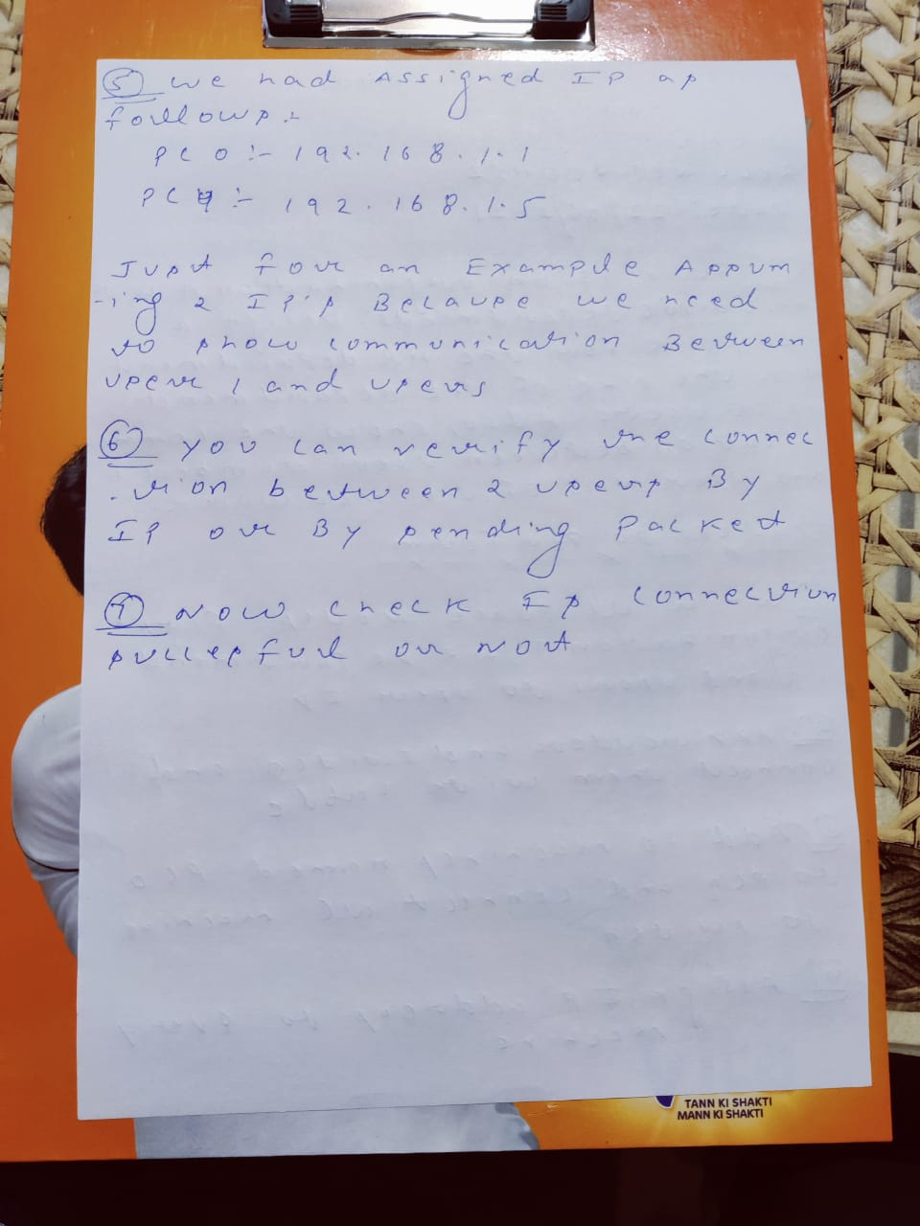

**Output Screenshots from Packet Tracer Q1**

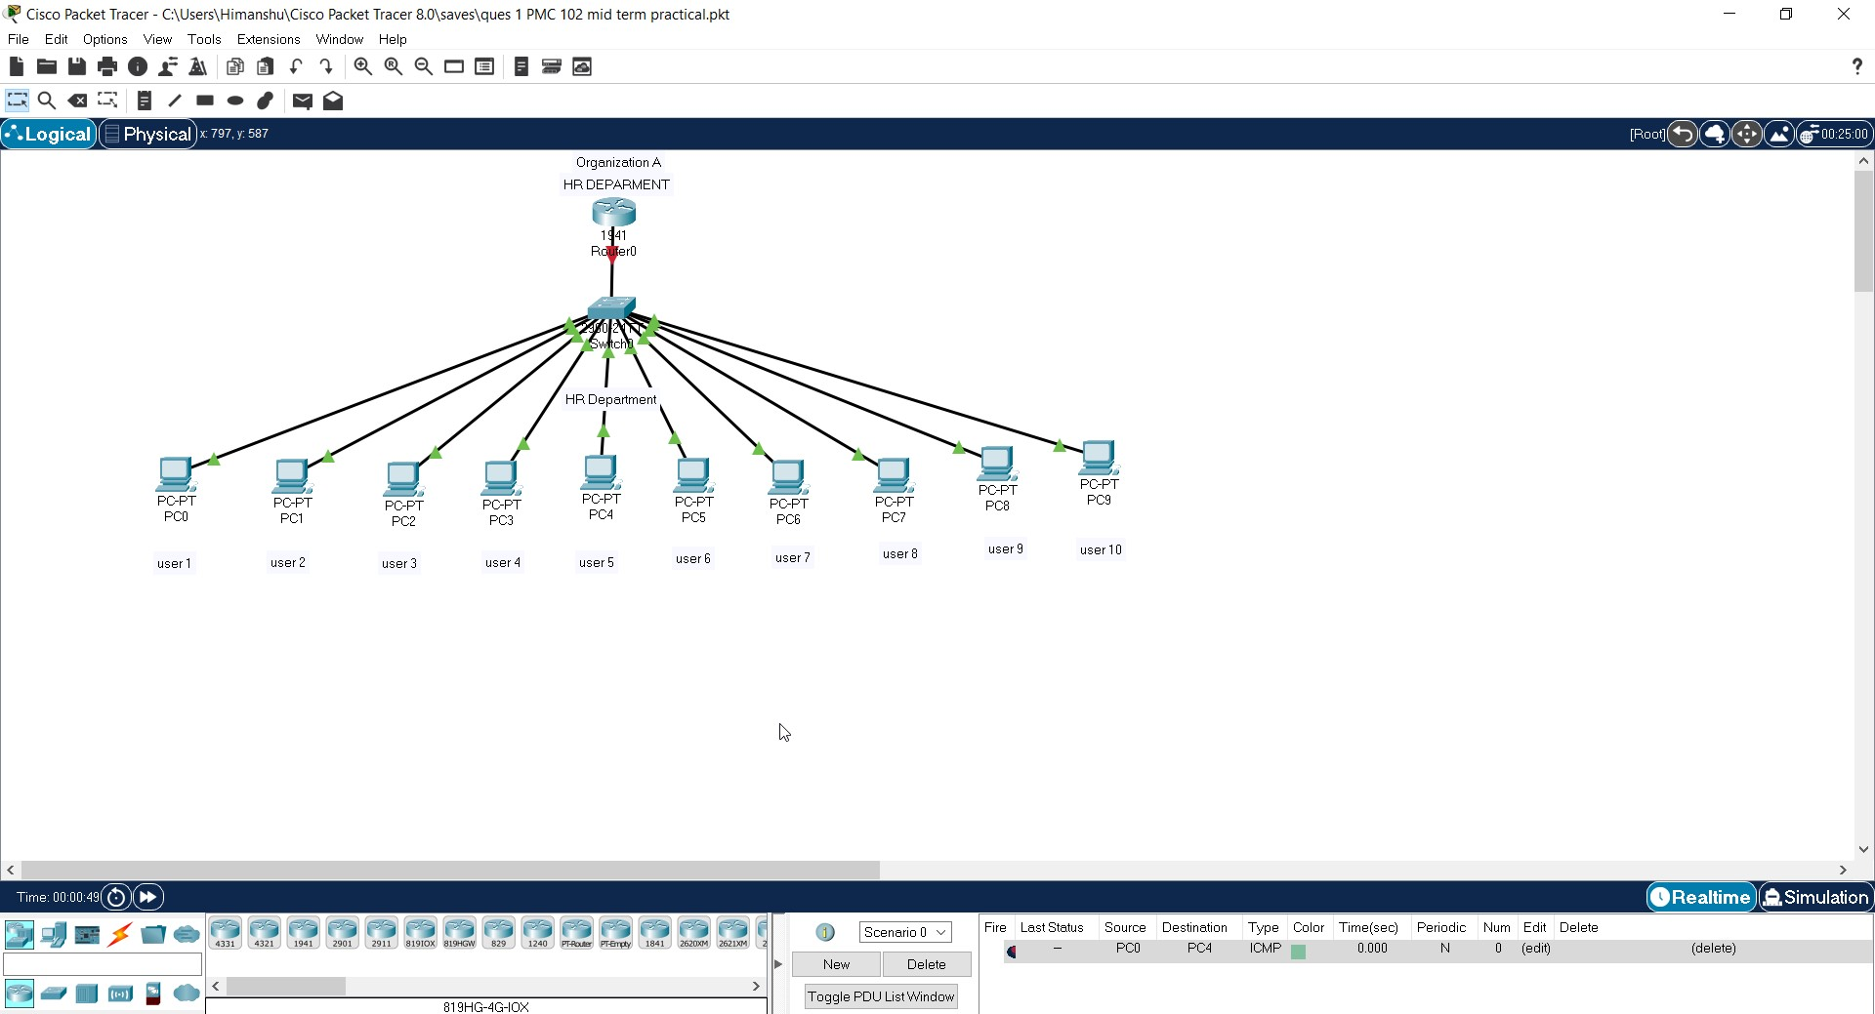

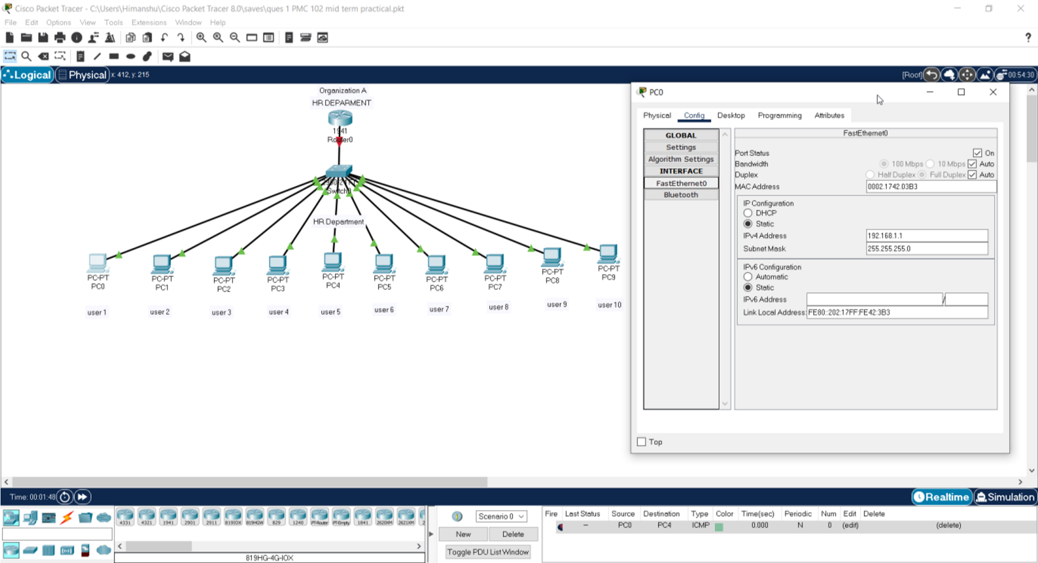

# IP assigned to User 1

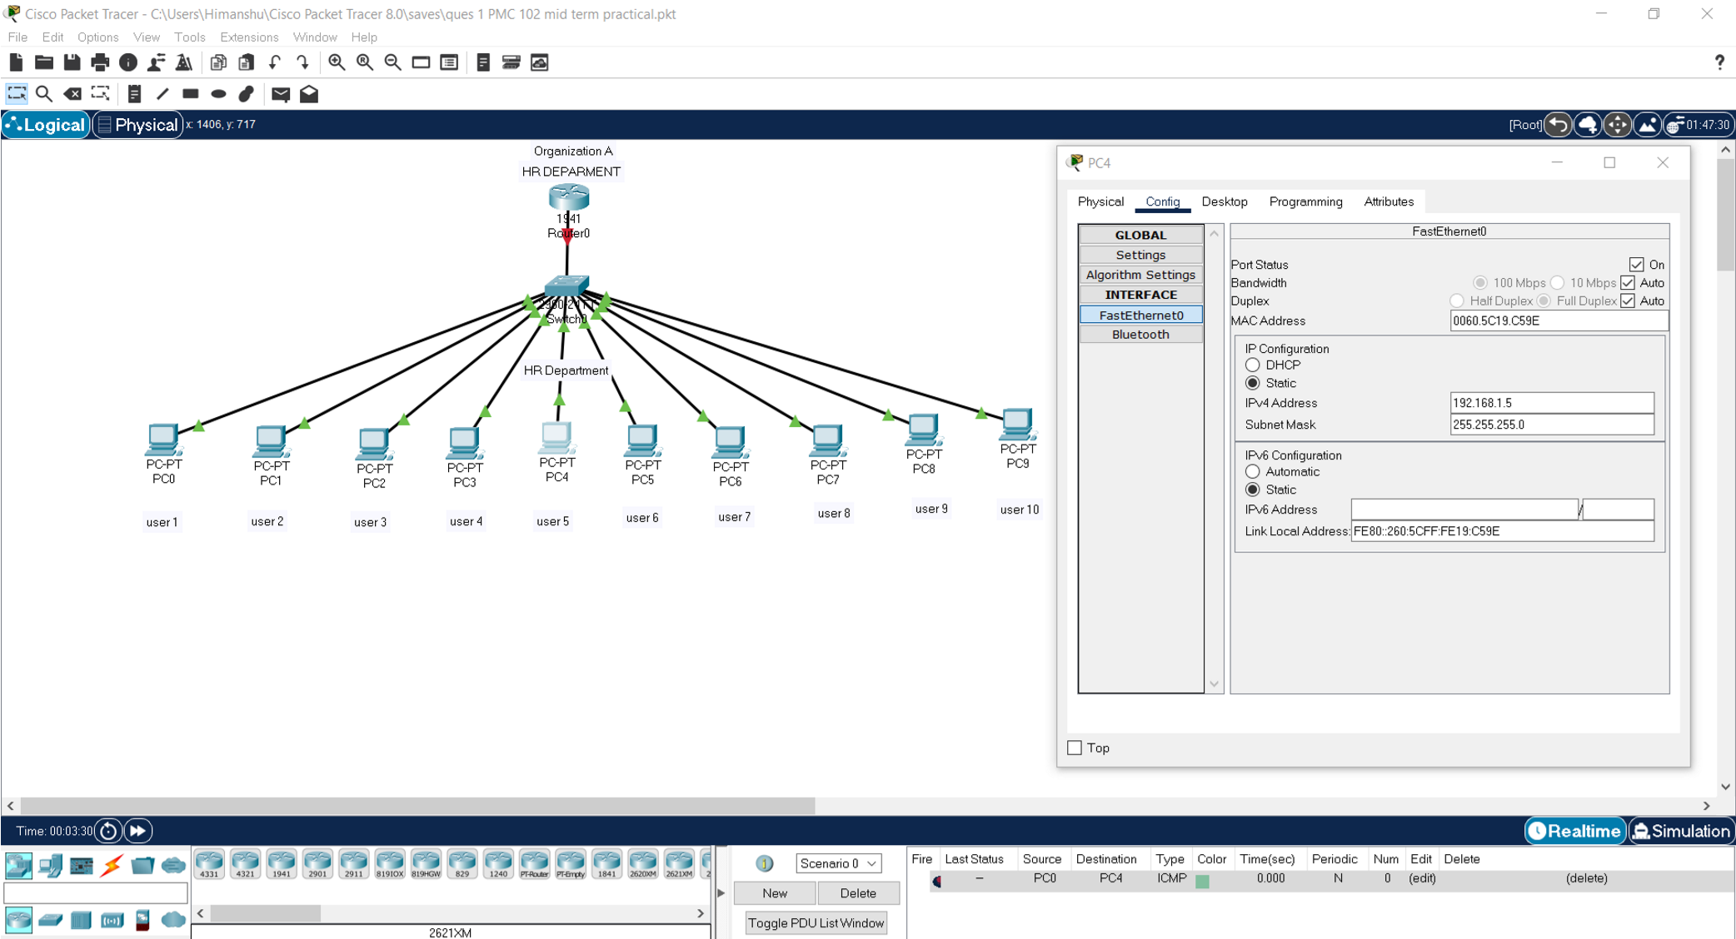

**IP Assigned to User 5**

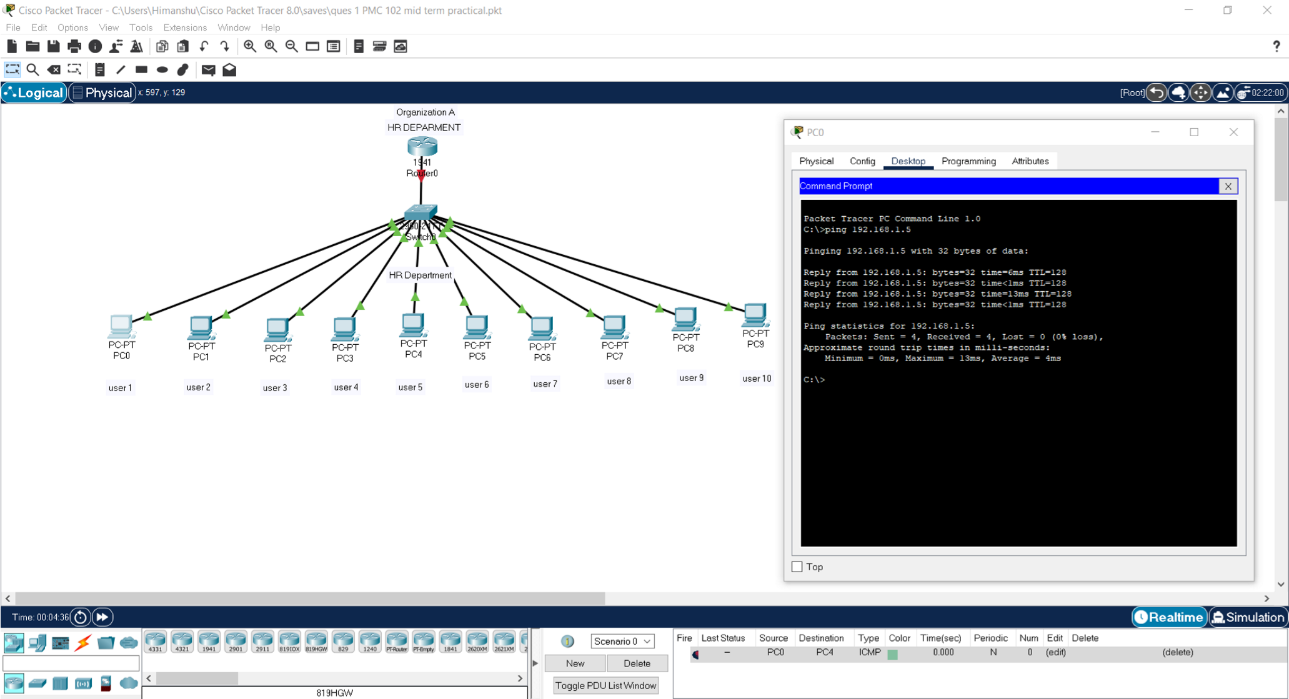

# Pinging User 1 to User 5. Successful

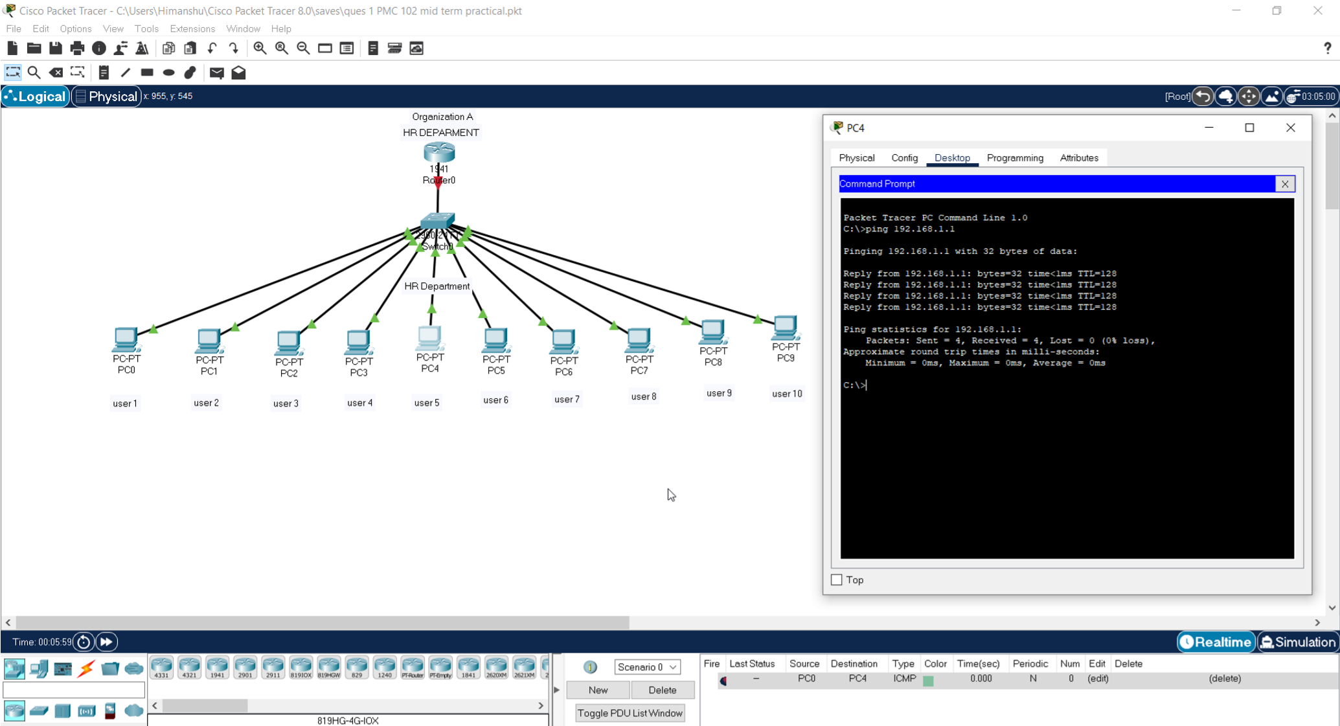

# Pinging User 5 to User 1. Successful

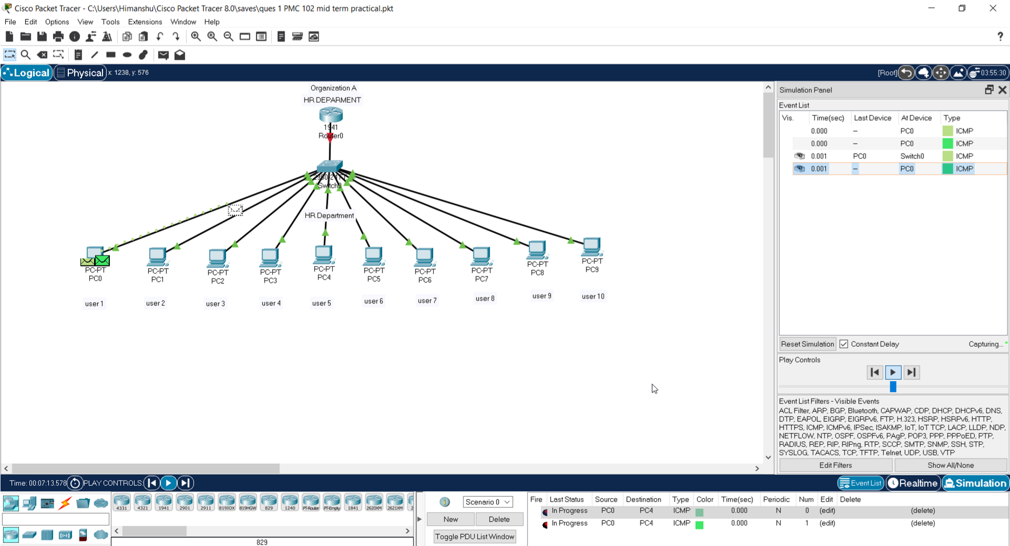

# Sending PDU from User 1 to User 5 In simulation Mode

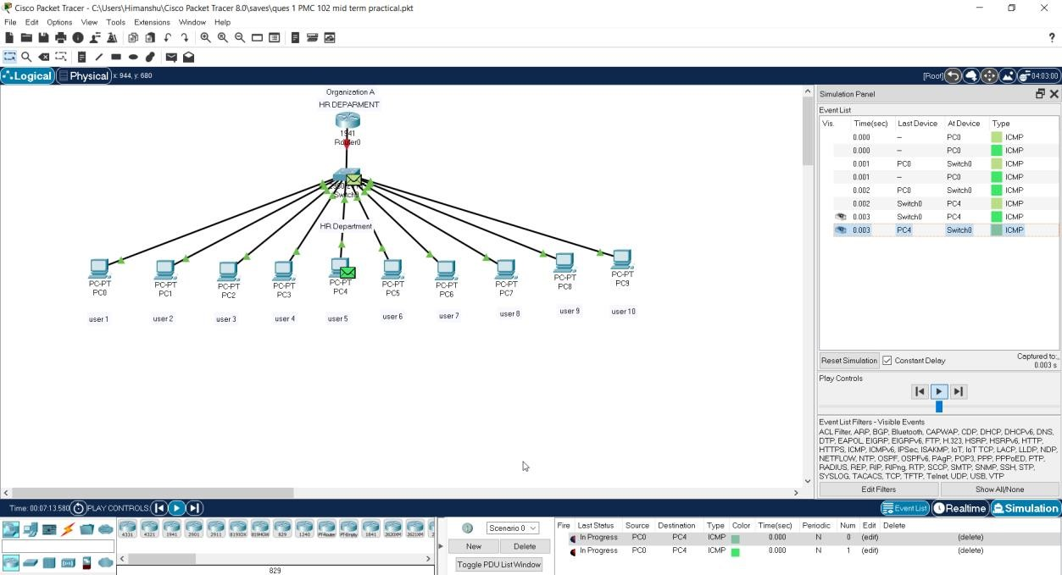

# Packet Received by User 5 which was sent from user 1

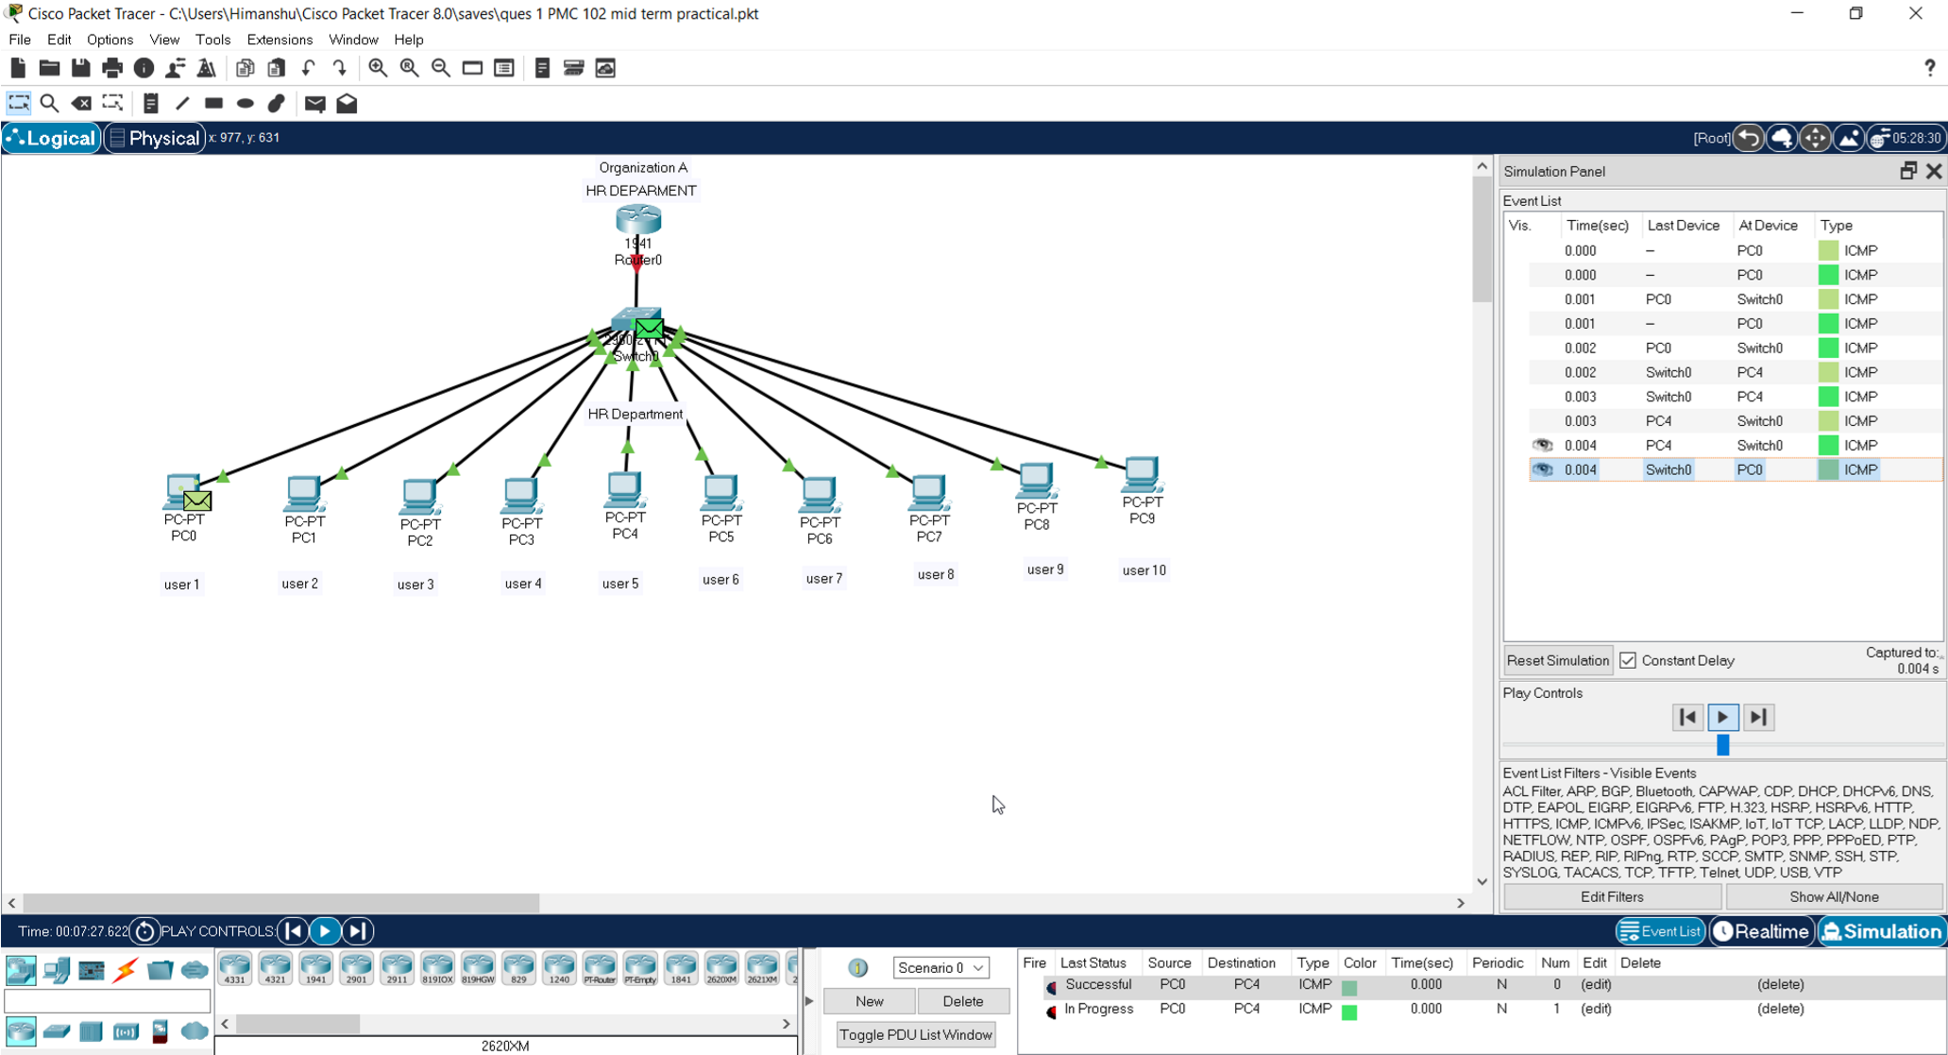

# Packet sent back to user 1 from user 5

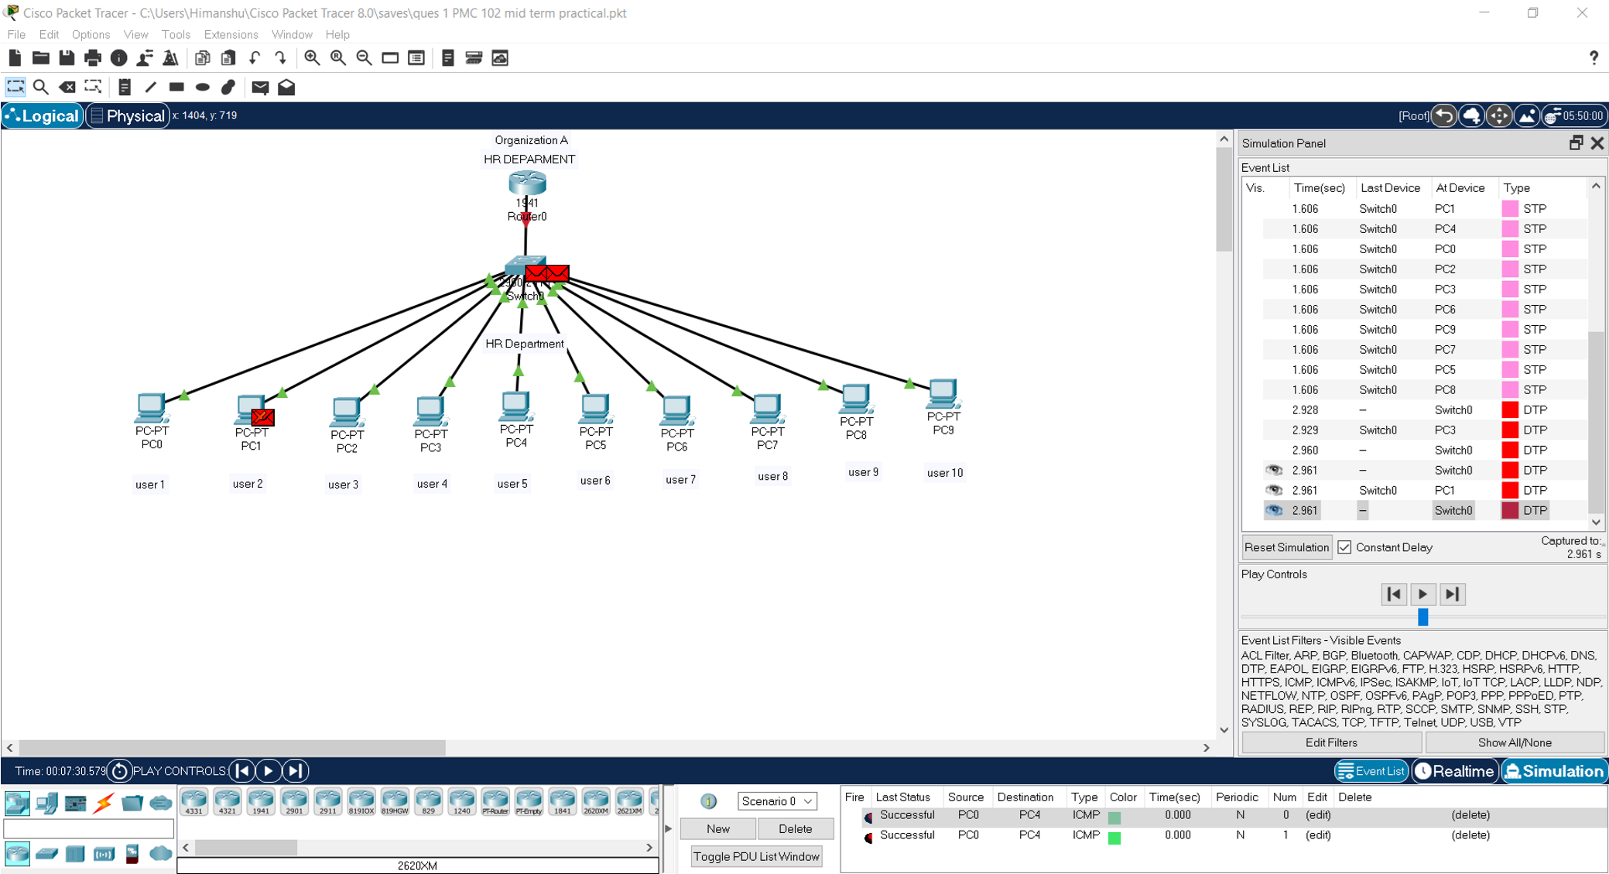

# Here we can see Successful Message at right bottom corner.

# Hence Connection is established and working.

# Question 2

2. There are two organizations in a city named GEU and GEHU, design a network between the SOC department of GEU and GEHU. Also, show the communication between user number 1 of GEU and user number 2 of GEHU.

**Output Screenshots from Packet Tracer Q2**

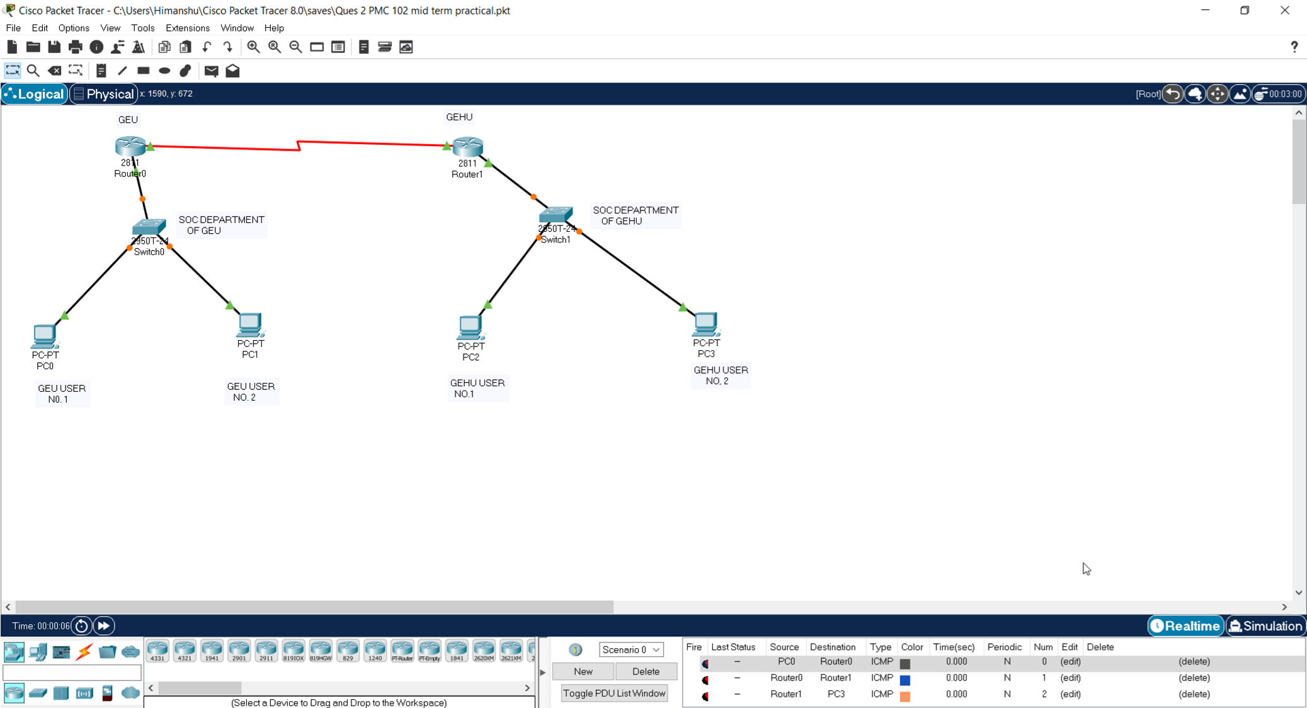

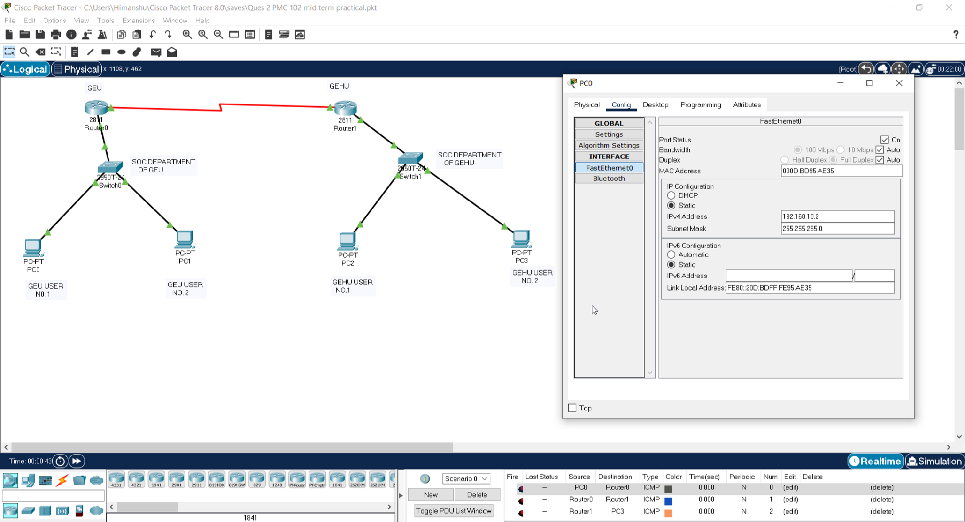

# IP assigned to User 1 of GEU. 192.168.10.2

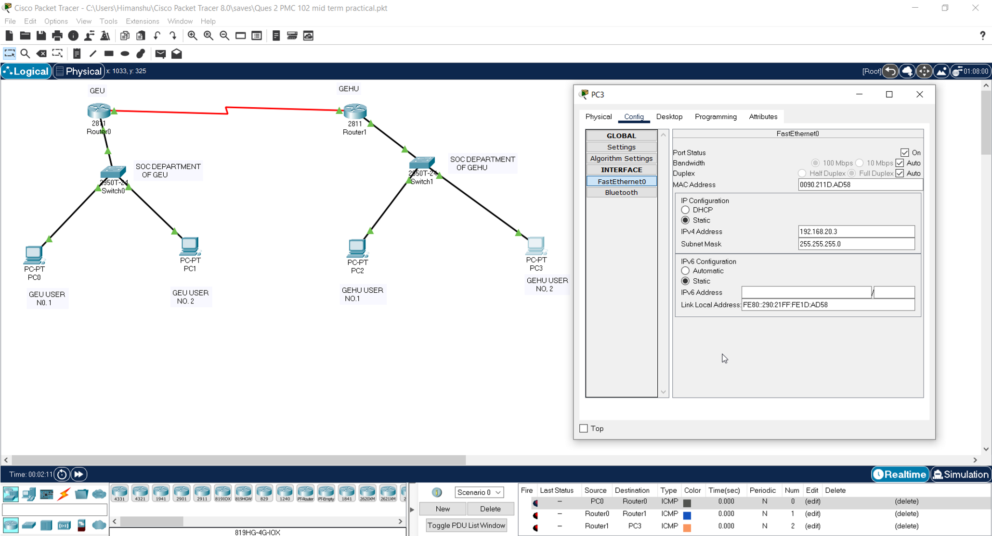

# IP assigned to User 2 of GEHU. 192.168.20.3

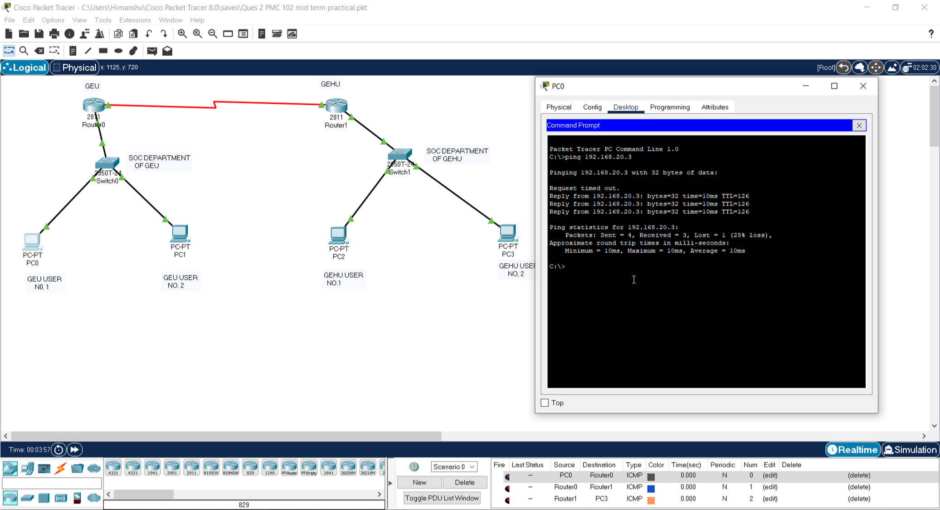

# Pinging User 2 of Gehu from User 1 of GEU

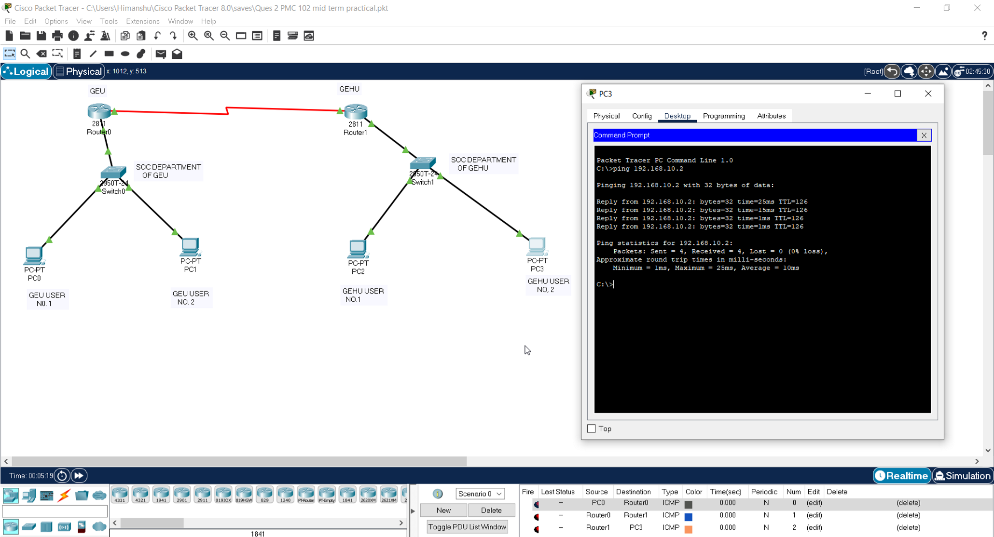

# Pinging user 1 of Geu from user 2 of GEHU

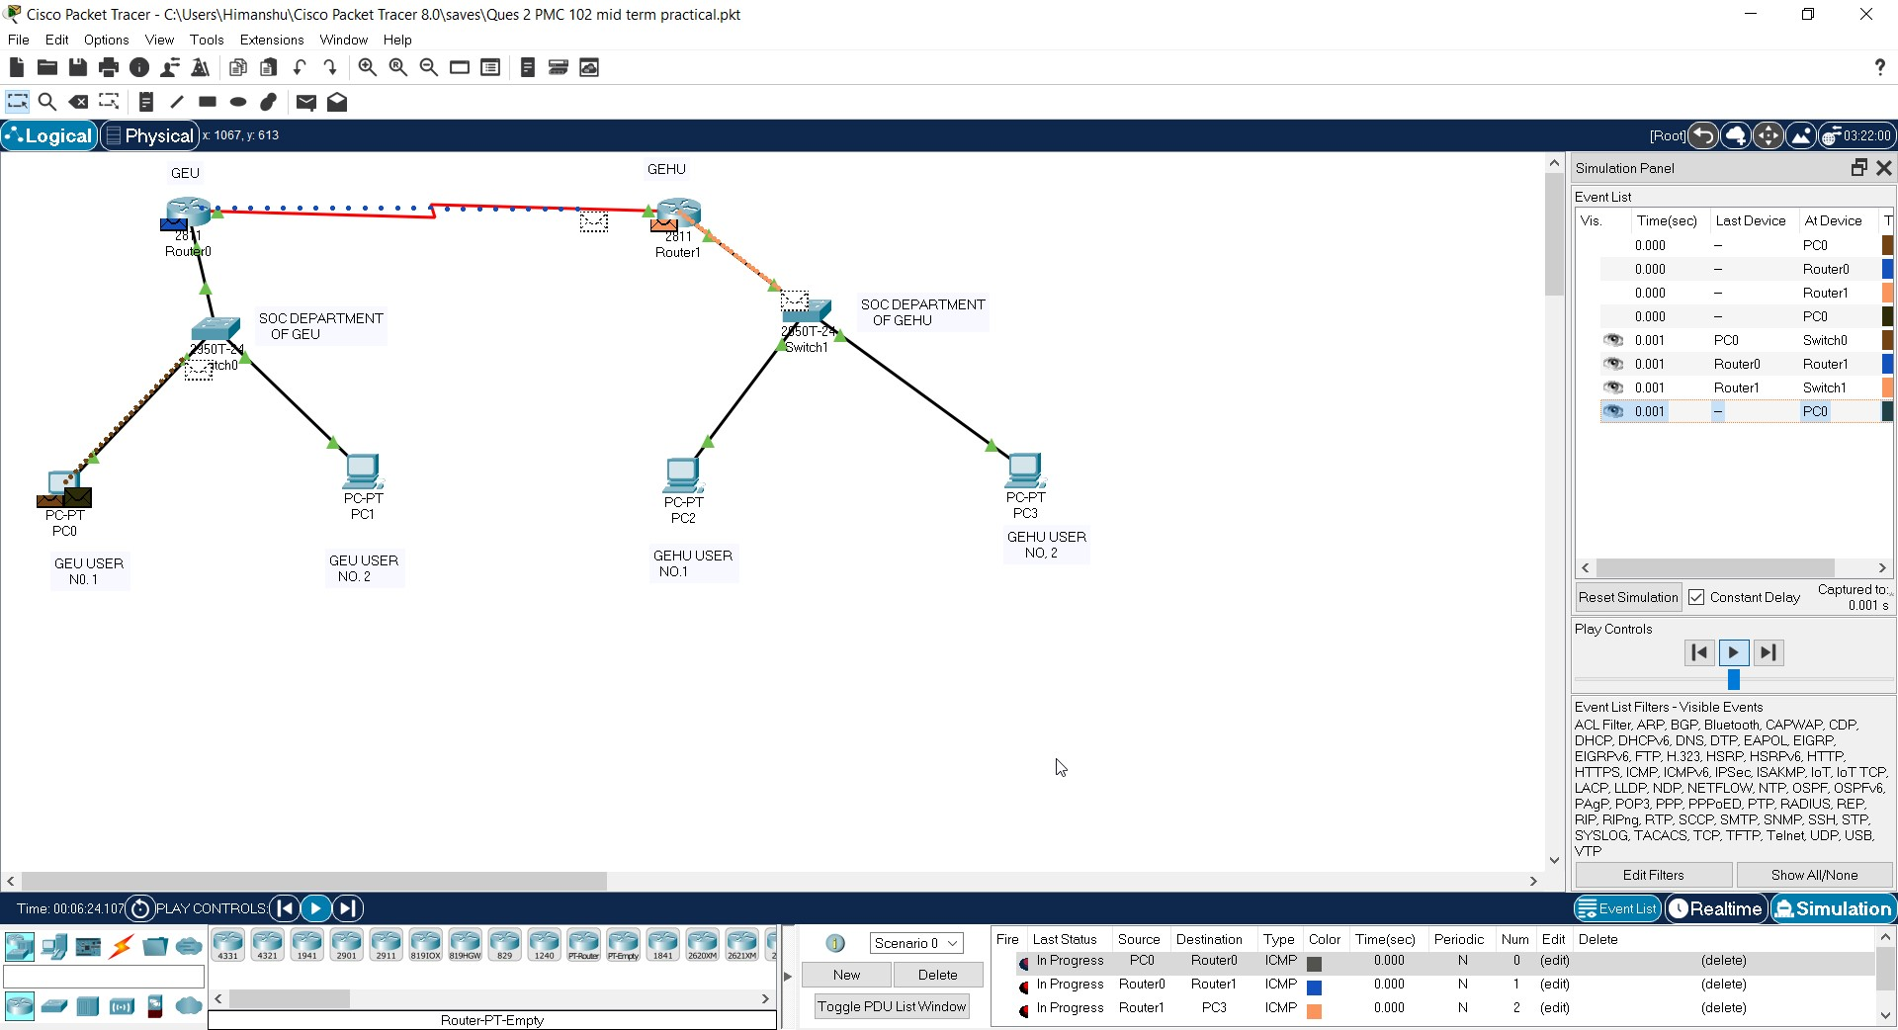

# PDU being sent to User 2 of GEHU from User 1 of GEU

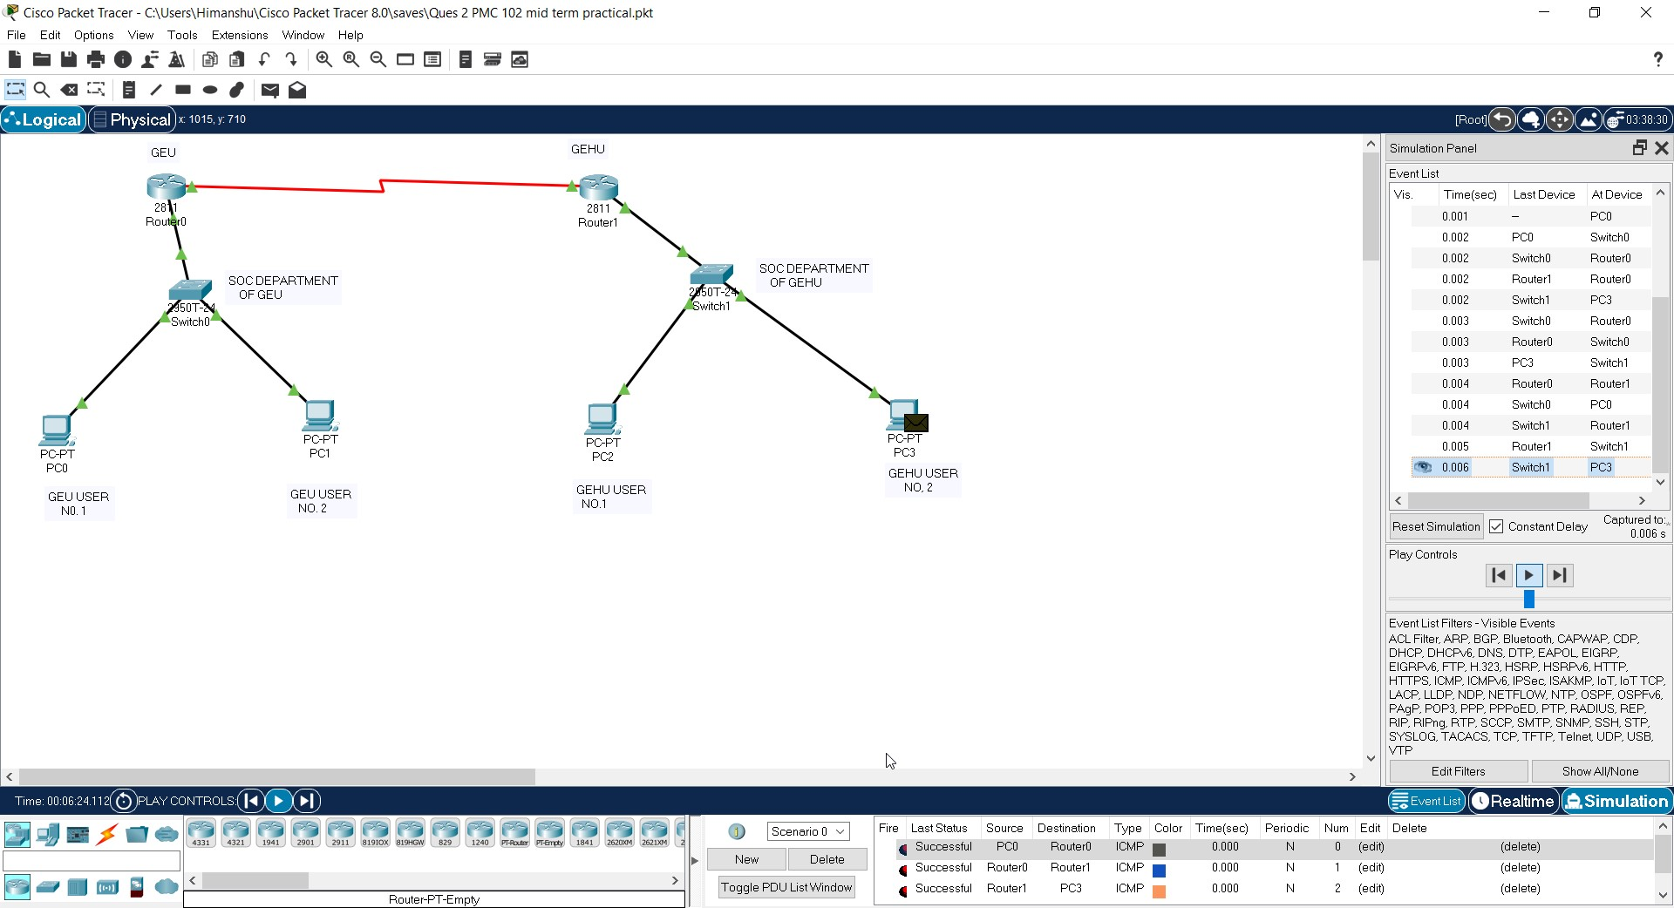

# PDU Received by User 2 of GEHU from User 1 of GEU

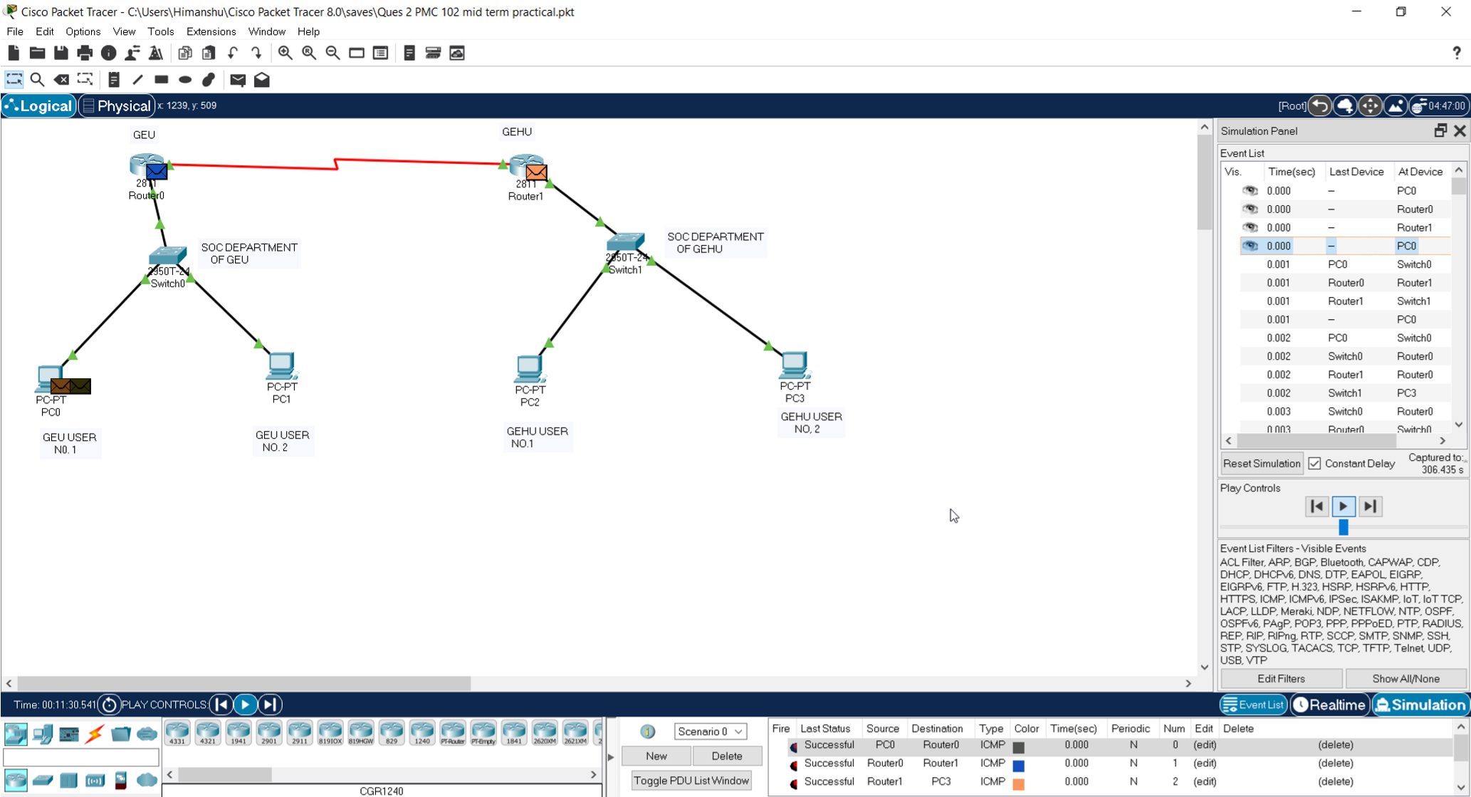

# PDU received back by user 1 of GEU from User 2 of GEHU

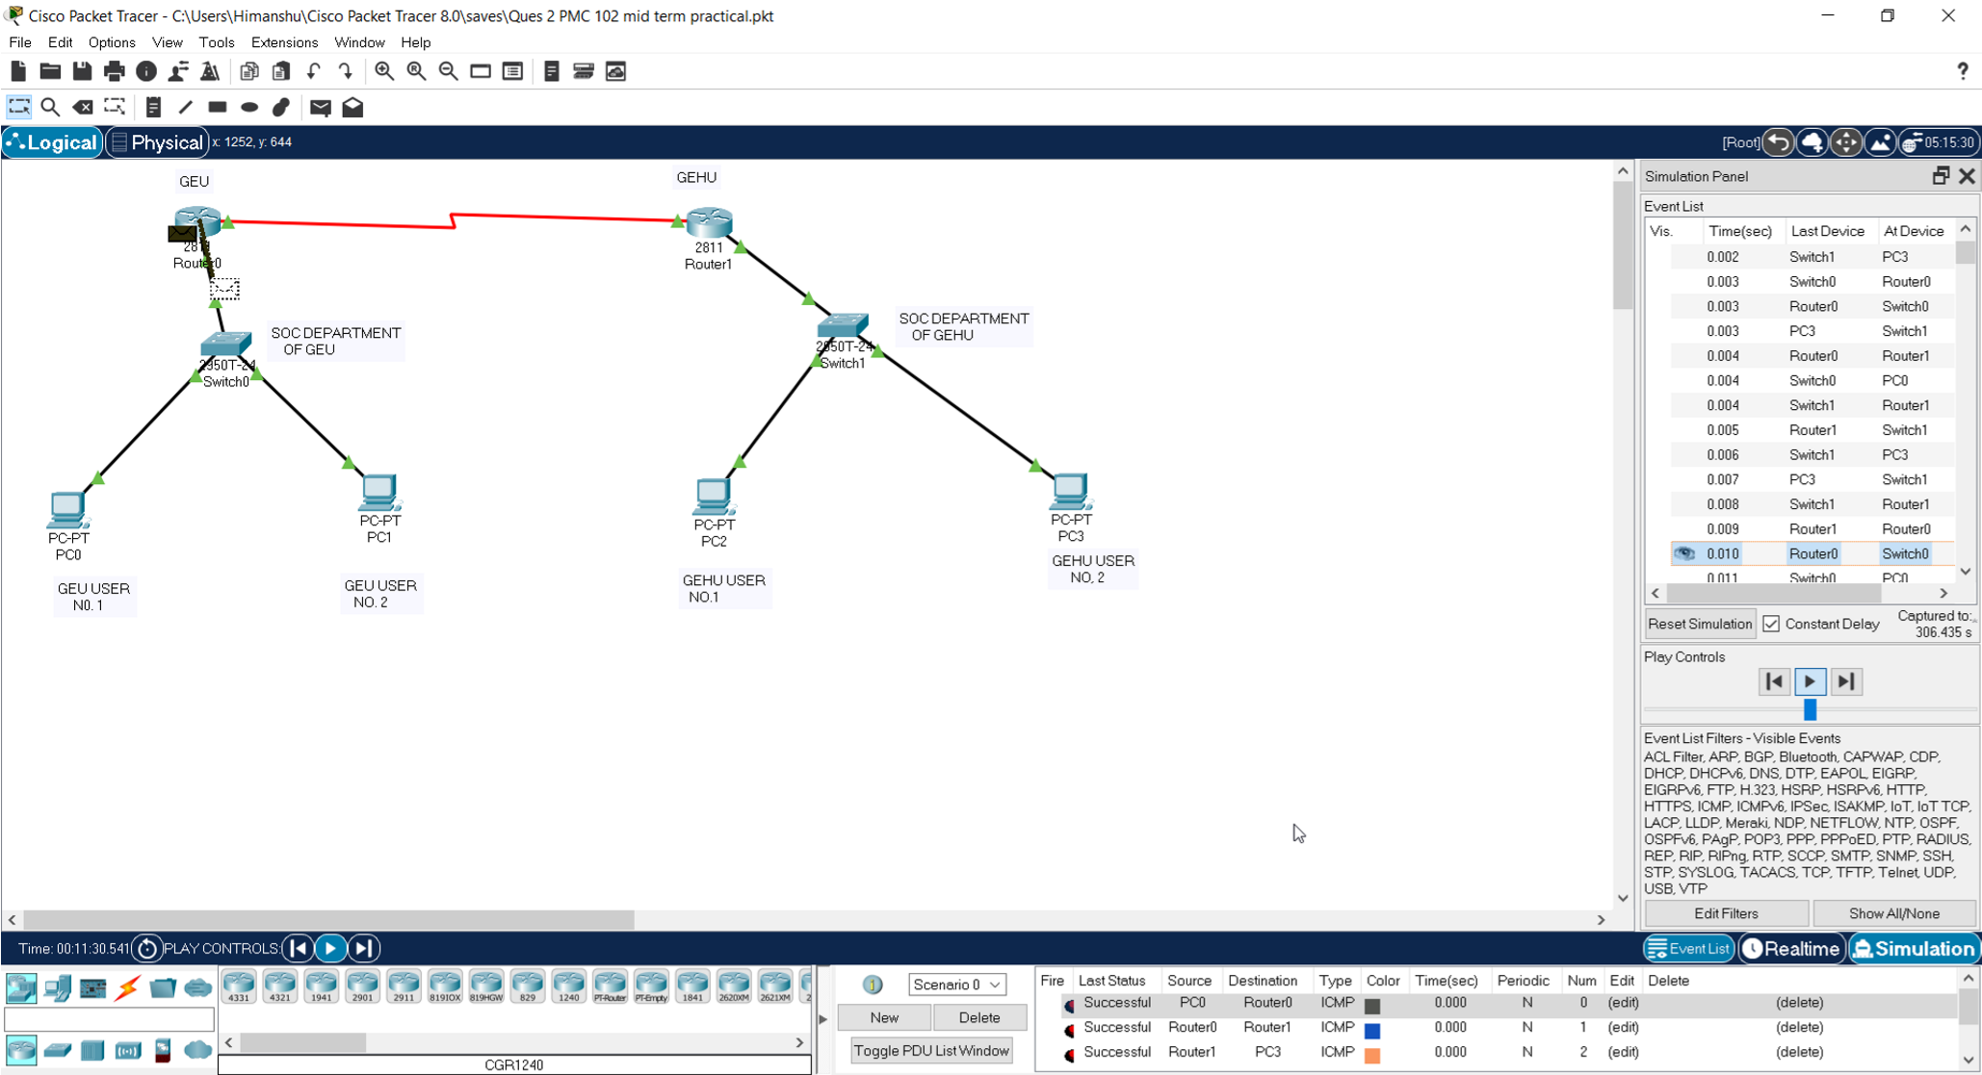

# Successfully established connection there from User 1 of GEU to user 2 of GEHU. Check Successful message at right bottom corner.

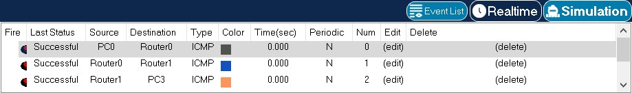

# PC 0 (GEU user 1) to PC 3 (GEHU user 2)

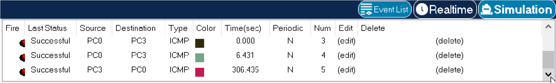

# PC 3 to PC0

# Successfully connection established in both ways.

**Submitted by:- Sudarshan Tomar (Gehu) , STD ID:- 20711156**